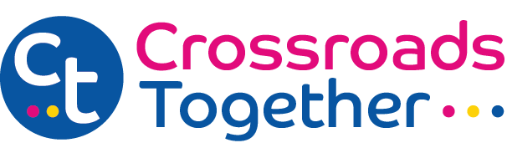

Crossroads Care Cheshire, Manchester and Merseyside Ltd Trading As Crossroads Together
Gift Aid Declaration
Details of donor:

Title ---------------------------------------------------------------

Forename(s) ----------------------------------------------------------------

Surname -----------------------------------------------------------------

Home Address -----------------------------------------------------------------

-----------------------------------------------------------------
Post Code ----------------------------------------------------

I want the charity to treat (please tick all that apply):

The enclosed donation of £…….. as a Gift Aid Donation

The donation(s) of £…….. which I made on …../…../….. as (a) Gift Aid donation(s)

All donations that I make from the date of this declaration, until I notify you otherwise, as Gift Aid donations
All donations that I have made for the four years prior to this year and all donations I make from the date of this declaration, until I notify you otherwise, as Gift Aid donations

You must pay an amount of Income Tax and / or Capital Gains Tax at least equal to the tax that the charity reclaims on your donations in the appropriate tax year (currently 25p for each £1 you give)

Donor’s signature ------------------------------------------------------------------------------------------

Date ----------------
Notes:

- You can cancel this Declaration at any time by notifying the charity.
- If in the future your circumstances change and you no longer pay tax on your income and capital gains equal to the tax the charity reclaims, you can cancel your Declaration.
- If you pay tax at the higher rate you can claim further tax relief on your self assessment tax return.
- If you are unsure whether your donations qualify for Gift Aid Tax Relief ask the charity or refer to help sheet IR65 on the HMRC website.
- Please notify the charity if you change your name and address.

Please either email the form to help@crossroadstogether.org.uk or post it to:
Overton House, West Street, Congleton, CW2 1JY

Crossroads Care Cheshire, Manchester and Merseyside Limited trading as Crossroads Together. Registered charity No 1075268. Registered office: Overton House, West Street, Congleton, Cheshire, CW12 1JY. A company limited by guarantee registered in England No. 3554493. Registered with the Care Quality Commission. Patrons: Rt Hon Lord Bradley, Fiona Bruce MP & Sir Nicholas Winterton.

